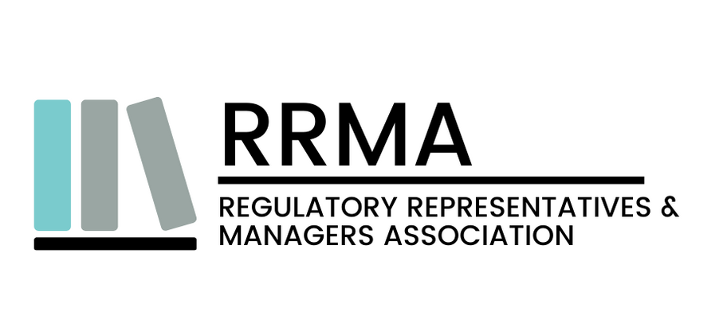
Draft Certified Regulatory Compliance Professional Certification Scheme (CRCPCS)
Public Consultation Feedback Form
1. Introduction
The Regulatory Representatives and Managers Association (RRMA) invites stakeholders, industry experts, certification bodies, academia, regulatory authorities, employers, and interested parties to provide comments on the draft Personnel Certification Scheme documents released for public consultation.
The purpose of this consultation is to ensure that the certification schemes are:
- technically robust and industry-relevant;
- fair, transparent, and practical for implementation;
- aligned with applicable regulatory and professional expectations;
- consistent with the principles of ISO/IEC 17024:2012; and
- developed through an open and impartial stakeholder consultation process.
RRMA welcomes constructive comments, recommendations, and technical inputs on all aspects of the draft scheme documents, including competence requirements, eligibility criteria, examination methodology, recertification requirements, ethics provisions, and scheme governance mechanisms.
Please complete this form and submit your comments before the consultation deadline. Separate forms may be submitted for different scheme documents, if required.
Consultation Period: From 22-05-2026 to 20-07-2026
Submission Email: info@rrma-global.org (Kindly use the Subject Line: Public Consultation Feedback – RRMA Certification Scheme)
2. Stakeholder Information
Field | Details
Full Name
Organization / Institution
Designation
Stakeholder Category | ☐ Regulatory Professional ☐ Industry Representative ☐ Certification Body ☐ Academic / Trainer ☐ Government / Regulatory Authority ☐ Consultant ☐ Trade Association ☐ Consumer Representative ☐ Other: __________
Country
Email Address
Contact Number
Would you like your comments to remain confidential? | ☐ Yes ☐ No

3. General Comments on the Scheme Documents
Please provide your overall observations on the draft certification scheme documents. Comments may include, but are not limited to:
- Scope and applicability of the scheme
- Structure and clarity of the documents
- Alignment with industry practices
- Competence requirements
- Examination and assessment methodology
- Ethical requirements
- Certification validity and recertification requirements
- Impartiality and governance considerations
- Practical implementation concerns
General Comments:

4. Specific Technical Comments
Please provide specific comments against the relevant document, clause, or requirement. Additional rows may be added as necessary.
Sr. No. | Document Name / Reference | Clause / Section / Annexure | Current Statement | Comment / Suggested Change | Technical Justification / Rationale
1
2
3

5. Declaration
I hereby confirm that:
- the comments provided are made in good faith and based on my professional knowledge, technical expertise, and/or practical experience;
- the feedback is intended to support the transparent and effective development of the RRMA Personnel Certification Scheme; and
- the information submitted does not knowingly violate any confidentiality, intellectual property, or legal obligations.

Name: ______________________________
Signature: ______________________________
Date: ____ / ____ / ______

6. Submission Instructions
Please submit the completed feedback form along with supporting documents (if any) to:
Email: info@rrma-global.org (Kindly use the Subject Line: Public Consultation Feedback – RRMA Certification Scheme)
Late submissions may not be considered during the current consultation cycle. RRMA reserves the right to review, consolidate, accept, or reject comments based on technical relevance, regulatory considerations, and scheme objectives.

Disclaimer
The draft scheme documents circulated for public consultation are preliminary working drafts issued by the Regulatory Representatives and Managers Association (RRMA) solely for stakeholder review and consultation purposes. These documents are subject to revision, amendment, or withdrawal based on comments received during the consultation process and subsequent technical review.
The draft documents do not constitute final certification requirements, accreditation criteria, contractual obligations, regulatory guidance, or legally binding instruments. RRMA does not guarantee that any recommendation or comment received will be incorporated into the final version of the scheme documents.
All intellectual property rights relating to the scheme documents remain the exclusive property of RRMA. Reproduction, circulation, or distribution of the draft documents is permitted only for review, consultation, and feedback purposes with appropriate acknowledgement to RRMA.
© 2026 RRMA. All Rights Reserved.

